1.  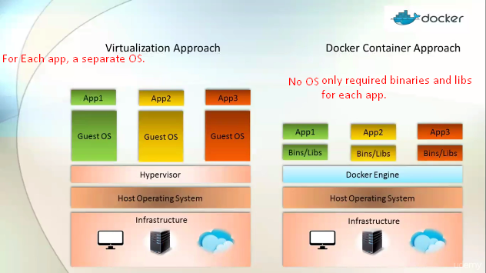.
2. **Virtualization**:
   1. We have 3 layers. 🡺 Infrastructure🡺Host OS 🡺 Hypervisor.
   2. Hypervisor allows us to share physical resources among the virtual machines (Guest Oss).
   3. Many brands of Hypervisors in market such as 🡺 VMware. But their core responsibility is to manage the resources b/w virtual machines.
   4. But the problem is that, for each virtual machine, there is dedicated OS. So, it becomes difficult by IT Team.
3. So, Docker team came out of this with the philosophy of sharing base OS with multiple applications as we share base hardware with applications in case of virtual machine. They called this container not VM. So, Docker is sharing host OS with containers.